
四川恒诚致远生物科技有限公司
Naturewill biotechnology Co., Ltd.

产品分析证书
Certificate of Analysis

产品信息(Product Information)
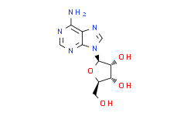
产品编号（CAT No.）: N2635 中文名称：腺嘌呤核苷 English Name：Adenosine CAS No.: 7432-28-2
分子式 (M. F.): C10H13N5O4
分子量 (M. W.): 267.24
批号 (Batch No.): N2306263505

检测项目及结果（Specifications&results）

项目Item | 指标Spe. | 结果Results
Purity （HPLC） | Adenosine≥98% | 99%
外观Appearance | White powder | Conforms
物理特性Physical characteristics
颗粒大小Particle-size | NLT100% 80目 | Conforms
失重Loss on drying | ≤2.0% | 1.52%
重金属Heavy metal
总金属Total metals | ≤10.0ppm | Conforms
铅Lead | ≤2.0ppm | Conforms
汞Mercury | ≤1.0ppm | Conforms
镉Cadmium | ≤0.5ppm | Conforms
微生物Microorganism
细菌总数Total number of bacteria | ≤1000cfu/g | Conforms
酵母菌Yeast | ≤100cfu/g | Conforms
大肠杆菌Escherichia coli | Not included | Not detected
沙门氏菌Salmonella | Not included | Not detected
葡萄球菌Staphylococcus | Not included | Not detected
结论Conclusions | 合格Qualified

贮存条件（Storage）:2~8℃, protected from light, keep package airproofed. <-15℃ when not in use for a long time.（密封保存，置 于阴凉干燥处，长期不使用最好放置于-15℃以下环境中）
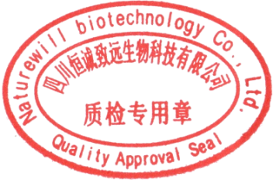
温馨提示（Reminder）:The sample solutions should be prepared immediately before use.(请现配现用)
QC: Ben Yang

QA: Joy Li

产品售后 (After-sale service):In case of quality issue, please contact us within 15 days after receipt of the product.（若对于我们的产 品质量有任何疑问，请于收到货后 15 天内联系我们）

四川省成都市温江区海科路东段 777 号
www.naturewill.cn 1
service@naturewill.cn

